Contents

1. Modules, packages and libraries 2

2. The standard library and library functions 9

3. Adding more python libraries 10

4. Numpy Library 11

# Modules, packages and libraries

**Module**

The module is a simple Python file that contains collections of functions, classes and global variables and with having a .py extension file.

Example of modules are Datetime, Random, Math etc.

**Example (random module):**

|  |
| --- |
| import random  print(random.random())  print(random.uniform(2.1, 5.4))  print(random.randint(2, 10))  print(random.randrange(1, 10, 2))  numbers = [1, 3, 5, 7, 9]  random.shuffle(numbers)  print(numbers) |
| 0.4382587528646582  4.610697534556159  3  1  [9, 5, 7, 1, 3] |

Let’s play Guessing Game:

|  |
| --- |
| import random  print("Guessing Game: ")  magic_number = random.randint(1, 50)  guess = None  attempts = 0  while guess != magic_number:      guess = int(input("Enter a number between [1, 50]"))      attempts += 1        if guess < magic_number:          print("Try Higgher")        elif guess > magic_number:          print("Try Lower")      else:          print(f"You got correct ans i.e. {magic_number} in {attempts} attemps") |

**Example (math module):**

|  |
| --- |
| import math  print(math.pi)  print(math.e)  print(math.pow(2, 5))  print(math.sqrt(25))  print(math.factorial(5))  print(math.gcd(8, 12)) |
| 3.141592653589793  2.718281828459045  32.0  5.0  120  4 |

**Creating and using a module.**

|  |
| --- |
| Creating Module **calculation.py** |
| def add(a, b):      return a + b  def subtract(a, b):      return a - b  def multiply(a, b):      return a * b  def divide(a, b):      try:          return a / b      except ZeroDivisionError:          return "Denominator cannot be zero" |
| 1. Using module |
| import calculation  print(calculation.add(2, 3))  print(calculation.subtract(2, 3))  print(calculation.multiply(2, 3))  print(calculation.divide(2, 0)) |

In Python, there are several ways to import modules and specific parts of modules, each with its own use cases. Here are the most common methods:

1. **Importing the Entire Module**: import calculation
2. **Importing Specific Functions or Classes**: from calculation import add, subtract
3. **Importing All Names from a Module**: from calculation import *
4. **Importing a Module with an Alias**: import calculation as cl

|  |
| --- |
| **Importing Specific Functions or Classes** |
| from calculation import add, subtract  print(add(2, 3))  print(subtract(2, 3)) |
| **Importing All Names from a Module** |
| from calculation import *  print(add(2, 3))  print(subtract(2, 3))  print(multiply(2, 10))  print(divide(3, 4)) |
| **Importing a Module with an Alias**: |
| import calculation as cl  print(cl.add(2, 3))  print(cl.subtract(2, 3))  print(cl.multiply(2, 10))  print(cl.divide(3, 4)) |

**Math Module docs**

**Math Constants**

* **math.pi**: The mathematical constant π (pi), approximately 3.14159.
* **math.e**: The base of natural logarithms (Euler's number), approximately 2.71828.
* **math.tau**: The mathematical constant τ (tau), which is 2π, approximately 6.28318.
* **math.inf**: Represents positive infinity.
* **math.nan**: Represents a "Not a Number" (NaN) value.

**Math Methods**

* **math.sqrt(x)**: Returns the square root of x.
* **math.pow(x, y)**: Returns x raised to the power of y.
* **math.exp(x)**: Returns e raised to the power of x.
* **math.log(x, [base])**: Returns the logarithm of x to the specified base. If base is not provided, returns the natural logarithm.
* **math.log10(x)**: Returns the base-10 logarithm of x.
* **math.log2(x)**: Returns the base-2 logarithm of x.
* **math.sin(x)**: Returns the sine of x (in radians).
* **math.cos(x)**: Returns the cosine of x (in radians).
* **math.tan(x)**: Returns the tangent of x (in radians).
* **math.asin(x)**: Returns the arc sine (inverse sine) of x, in radians.
* **math.acos(x)**: Returns the arc cosine (inverse cosine) of x, in radians.
* **math.atan(x)**: Returns the arc tangent (inverse tangent) of x, in radians.
* **math.degrees(x)**: Converts angle x from radians to degrees.
* **math.radians(x)**: Converts angle x from degrees to radians.
* **math.ceil(x)**: Returns the smallest integer greater than or equal to x.
* **math.floor(x)**: Returns the largest integer less than or equal to x.
* **math.trunc(x)**: Truncates x to an integer, removing the fractional part.
* **math.fabs(x)**: Returns the absolute value of x (as a float).
* **math.factorial(x)**: Returns the factorial of x.
* **math.gcd(a, b)**: Returns the greatest common divisor of a and b.
* **math.isqrt(x)**: Returns the integer square root of x.
* **math.comb(n, k)**: Returns the number of ways to choose k items from n items without repetition (combinations).
* **math.perm(n, k)**: Returns the number of ways to arrange k items from n items (permutations).
* **math.copysign(x, y)**: Returns a float with the magnitude of x and the sign of y.
* **math.isfinite(x)**: Returns True if x is neither infinity nor NaN.
* **math.isinf(x)**: Returns True if x is infinity.
* **math.isnan(x)**: Returns True if x is NaN.
* **math.modf(x)**: Returns the fractional and integer parts of x as a tuple.
* **math.hypot(x, y)**: Returns the Euclidean norm, sqrt(x*x + y*y).
* **math.dist(p, q)**: Returns the Euclidean distance between points p and q, each given as a sequence (like a tuple).
* **math.fsum(iterable)**: Returns an accurate floating point sum of values in the iterable, avoiding intermediate rounding errors.
* **math.prod(iterable)**: Returns the product of all values in the iterable.

**Packages**

A package in Python is a way of organizing related modules into a directory hierarchy. Packages help you organize your code more logically and manage namespaces effectively, especially in larger projects. A directory that contains multiple modules and an optional special file __init__.py.

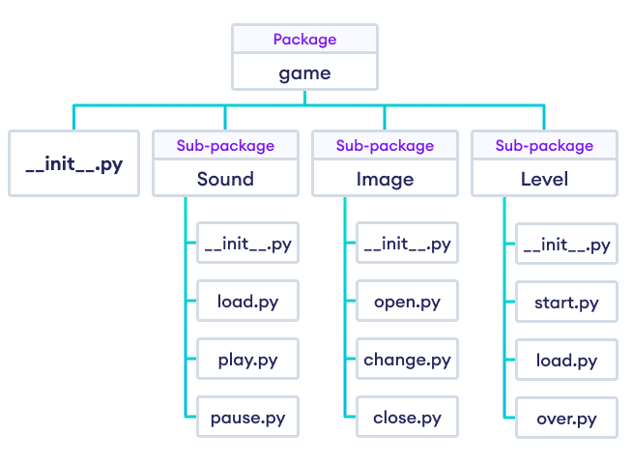A typical package:

mypackage/

│

├── __init__.py

├── module1.py

└── module2.py

Creating a package:

geometry/

│

├── __init__.py

├── calculations.py

└── area.py

|  |
| --- |
| calculations.py |
| def add(a, b):      return a + b  def subtract(a, b):      return a - b  def multiply(a, b):      return a * b  def divide(a, b):      try:          return a / b      except ZeroDivisionError:          return "Denominator cannot be zero" |
| area.py |
| import math  DEFAULT_RADIUS = 1  def area_of_circle(radius):      return math.pi * radius ** 2  def area_of_rectangle(length, breath):      return length * breath |
| example.py |
| from geometry.area import area_of_circle, DEFAULT_RADIUS  from geometry.calculations import add  a = 10  b = 20  radius = 2.4  print(f"Sum = {add(a, b)}")  print(f"Area of circle = {area_of_circle(radius)}")  print(f"Area of circle = {area_of_circle(radius=DEFAULT_RADIUS)}") |

**Library**:

A library is a collection of modules that provides a set of functions, classes, and tools to perform a specific set of tasks or solve particular problems. Libraries can be thought of as large packages or sets of packages that offer a broader range of functionality.

Third-Party vs. Standard Libraries:

* Standard Libraries: Python comes with a set of built-in libraries as part of the Python Standard Library. Examples include math, datetime, os, and json.
* Third-Party Libraries: These are developed and maintained by the Python community or organizations and are not included in the standard library. Examples include numpy, pandas, requests, and Django.

# The standard library and library functions

The Python Standard Library is a collection of modules and packages that are included with Python and provide a wide range of functionality. These modules and packages cover various programming tasks, such as file I/O, system operations, data manipulation, and more.

No need to install standard library separately; it comes bundled with the Python installation.

Here are some commonly used modules in the Python Standard Library along with their key functions:

1. math
   1. math.sqrt(x): Returns the square root of x.
   2. math.factorial(x): Returns the factorial of x.
   3. math.pi: Constant for the value of π.
2. datetime
   1. datetime.datetime.now(): Returns the current local date and time.
   2. datetime.date.today(): Returns the current date.
   3. datetime.timedelta(days=5): Represents a duration of 5 days.
3. os
   1. os.listdir(path): Returns a list of files and directories in path.
   2. os.mkdir(path): Creates a directory named path.
   3. os.path.join(a, b): Joins two or more pathname components.

|  |
| --- |
| from datetime import datetime, timedelta, timezone  print(datetime.now())  dt = datetime(2024, 8, 12, 14, 30, 0)  future_date = dt + timedelta(days= 5)  print(future_date)  utc_now = datetime.now(timezone.utc)  print(utc_now)  print(utc_now.astimezone()) |
| import os  cur_dir = os.getcwd()  print(cur_dir)  files = os.listdir('.')  print(files)  get_file = os.path.exists('myfile.txt')  print(get_file)  path = os.path.join('folder', 'subfolder', 'file.txt')  print(path) |

**The Python Standard Library includes over 200 modules and contains thousands of functions across its modules.**

# 3. Adding more python libraries

To expand your Python environment with additional libraries beyond the standard library, you can use the Python Package Index (PyPI), which hosts a vast collection of third-party libraries.

**Using pip to Install Libraries**

Syntax:

pip install library_name

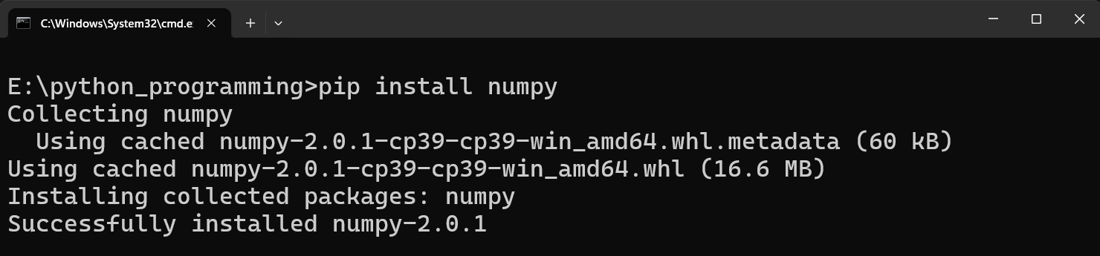Example: pip install numpy

# Numpy Library

NumPy (Numerical Python) is an open-source Python library that’s widely used in **science and engineering**. The NumPy library contains multidimensional array data structures, such as the homogeneous, N-dimensional ndarray, and a large library of functions that operate efficiently on these data structures.

|  |
| --- |
| import numpy as np  array1 = np.array([1, 2, 3, 4, 5])  print(array1)  array2 = np.zeros((2, 3))  print(array2)  array3 = np.ones((3, 2))  print(array3)  array4 = np.arange(10)  print(array4)  array5 = np.array([[1, 2, 3],                     [4, 5, 6]])  print(array5)  print(array5.shape)  print(array5.ndim)  print(array5.size)  print(array5.dtype) |

**Creating, Indexing, and Slicing NumPy Arrays**

Creating NumPy Arrays

Creating arrays with NumPy involves using functions like np.array(), np.zeros(), np.ones(), and np.arange()

|  |
| --- |
| #indexing and slicing  import numpy as np  array = np.array([10, 20, 30, 40, 50])  print(array[4])  matrix = np.array([[1, 2, 3],                      [4, 5, 6]])  print(matrix[1, 2])  print(array[0:4])  print(matrix[0:2, 1:3]) |

**Copying and Editing NumPy Arrays**

|  |
| --- |
| import numpy as np  array = np.array([1, 2, 3, 4, 5])  array_copy_1 = array                #shallow  array_copy_2 = array.copy()         #deep  print(array_copy_1)  print(array_copy_2)  array[2] = 20  print(array_copy_1)  print(array_copy_2) |

**Stacking and Restructuring NumPy Arrays**

Combining multiple arrays into a single array using functions like np.vstack() and np.hstack(). Changing the shape of an array using np.reshape().

|  |
| --- |
| import numpy as np  a = np.array([[1, 2], [3, 4], [5, 6]])  b = np.array([[7, 8], [9, 10], [11, 12]])  v_stack = np.vstack((a, b))  print(v_stack)  h_stack = np.hstack((a, b))  print(h_stack)  print(a)  reshaped = a.reshape((2, 3))  print(reshaped) |

Q. Convert 1D array to 2D Array

**Arithmetic Operations with NumPy Arrays**

|  |
| --- |
| import numpy as np  a = np.array([[1, 2],                [3, 4]])  b = np.array([[7, 8],                [9, 10]])  print(a + b)  print(a * b)  print(a * 2) |

**Operations with NumPy Arrays of Different Shapes**

|  |
| --- |
| import numpy as np  a = np.array([[1, 2],                [3, 4],                [5, 8]])  b = np.array([[7],                [8],                [9]])  print(a + b)        # Broadcasting addition |

**Concatenation, Reversion, and Persistence of NumPy Arrays**

|  |
| --- |
| import numpy as np  a = np.array([1, 2])  b = np.array([3, 4, 8])  concat = np.concatenate((a, b))  print(concat)  reversed_array = a[::-1]  print(reversed_array)  np.save('array.npy', b)  loaded_array = np.load('array.npy')  print(loaded_array) |

**Applications of numPy Random number generation**

|  |
| --- |
| import numpy as np  random_numbers = np.random.random(5)  print(random_numbers)  random_integers = np.random.randint(1, 10, size=5)  print(random_integers) |

**Applications of numPy Statistics**

|  |
| --- |
| import numpy as np  array = np.array([1, 2, 3, 4, 5])  mean = np.mean(array)  print(f"Mean: {mean}")  std_dev = np.std(array)  print(f"Standard Deviation: {std_dev}")  median = np.median(array)  print(f"Median: {median}") |

**Applications of numPy Linear algebra**

|  |
| --- |
| '''Consider the following system of linear equations:                      2𝑥+3𝑦=13                      4𝑥+9𝑦=30      A system of linear equations can be represented in matrix form as:                      A⋅X=B'''  import numpy as np  a = np.array([[2, 3],                [4, 9]])  b = np.array([13 , 30])  x = np.linalg.solve(a, b)  print(f'Solutions = {x}') |